Milestone 6 : Creation of Access Control Lists(Delete ACL)

Click New to create a new ACL(Delete)
- Enter the following details:
  - Type: record
  - Operation: Delete
  - Name: u_institution_details
  - Active: true
- In the Requires role related list, add:
  - bb4 (custom role)
- No need to add any Data condition
- Save the ACL Record
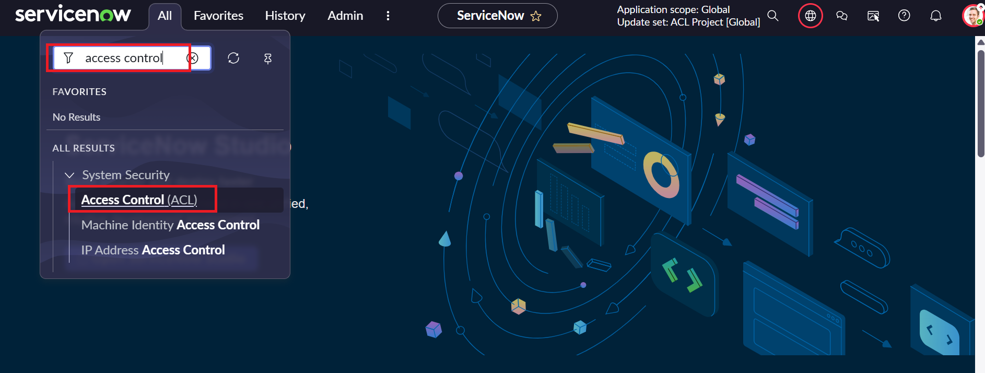
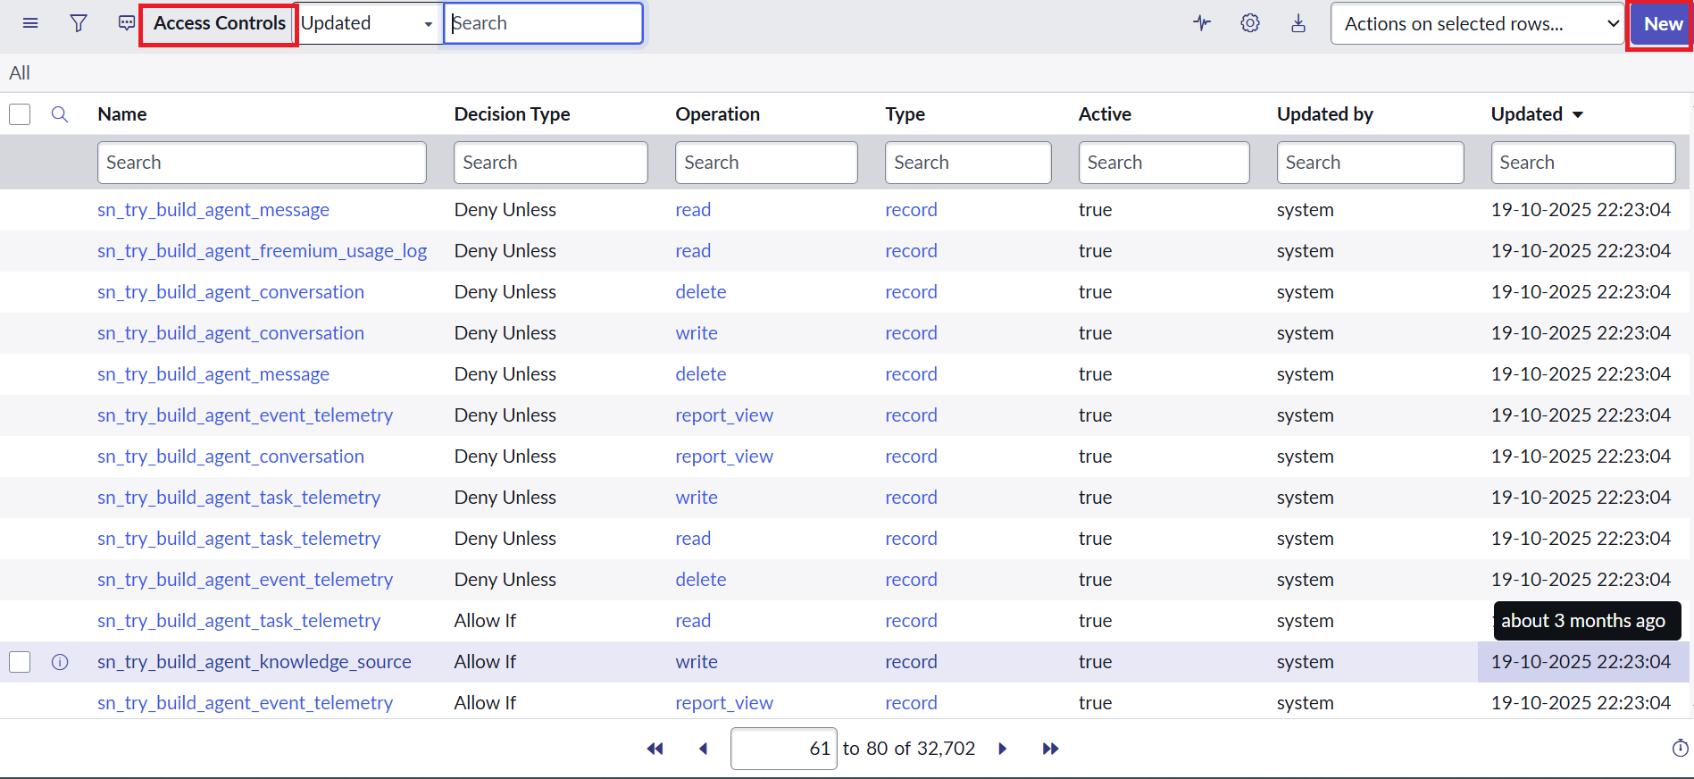

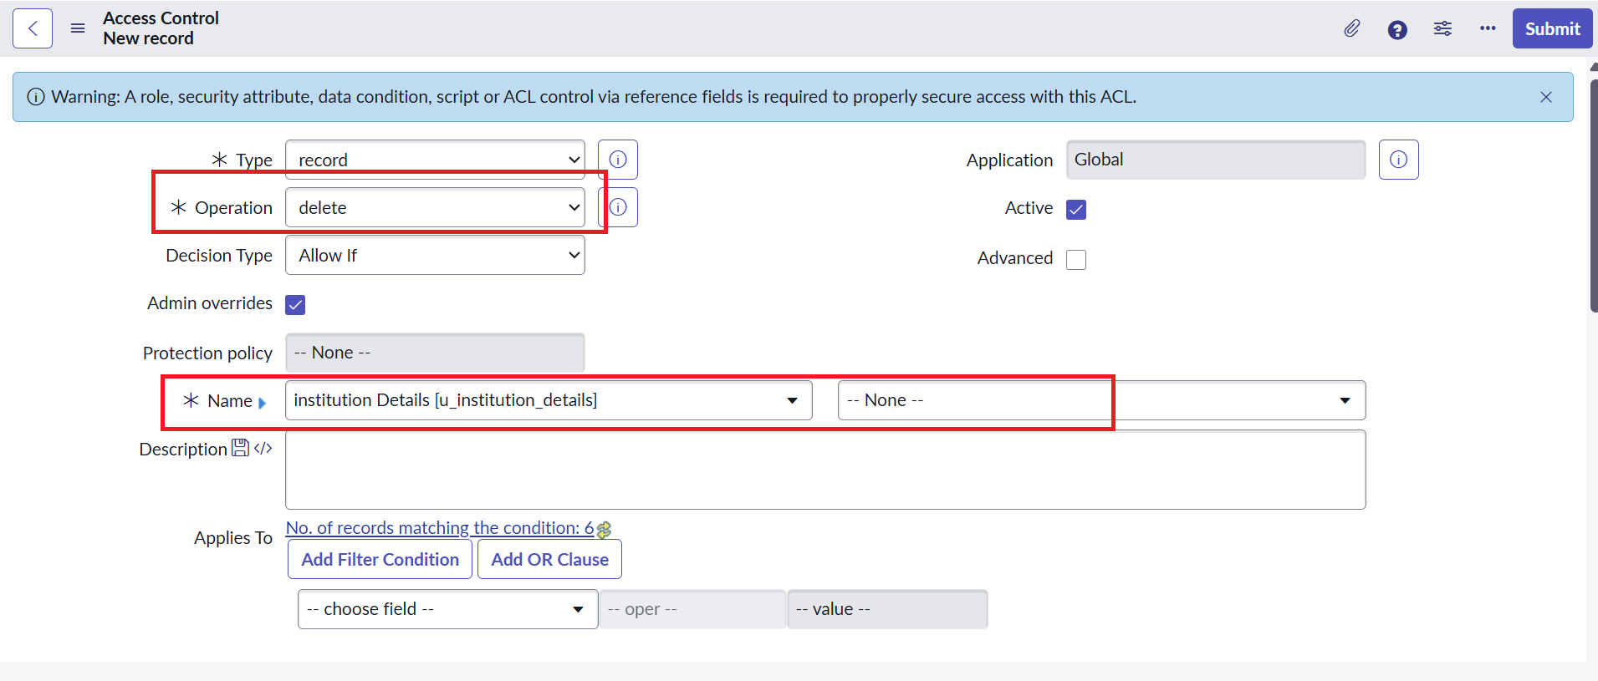
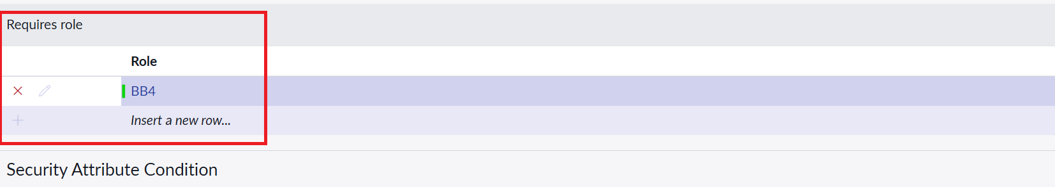

Verify :
- Users with bb1 &bb2 &bb3&bb4 roles can see, create and edit along with delete the EEE branch records.



